Sample Output

Customer Sign Up and Login

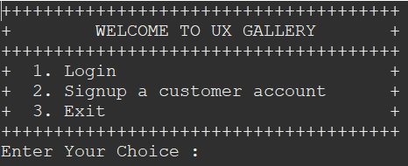
- First step, the application gives two options to user which is option 1 is to login for existing customers and option 2 for new customers to sign up. The user can exit the application by choosing option 3.

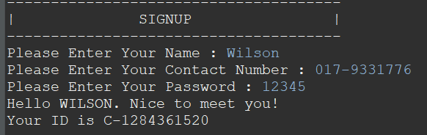
- The process when user choose option 2 to sign up to a new customer account. The program will ask the user to enter their name and contact number. New ID number will be given to new customer when they sign up for new account. The user also have to set a password so that the user can login using the user ID and password later on.

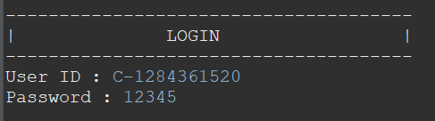
- After signing up for new customer, the program will return to main page. The user now can login using the user ID given when signing up and enter the password that the user set when signing up for new customer. If the user login with incorrect ID and password, the login will be failed.

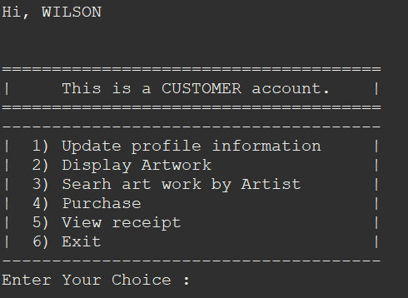
- After loging in, there will be several options for the customers to choose. The customer can update their profile information such as updating name, contact number and changing the password by choosing option 1.

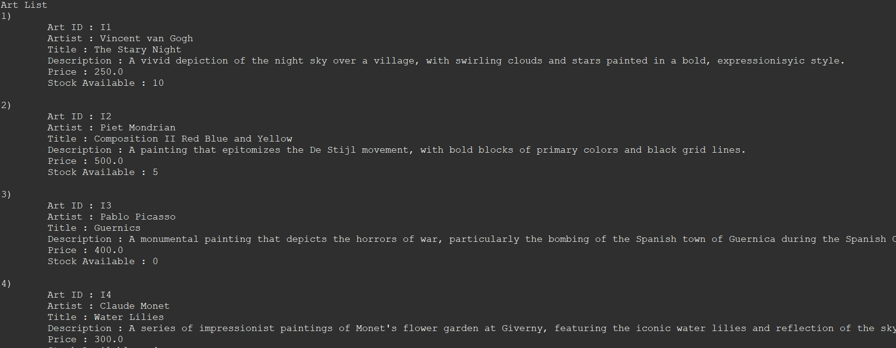
- Customer can view the artwork list by choosing the option 2. Customer able to decide which artwork they are interested because every detail has been displayed such as stock availability and including the price.

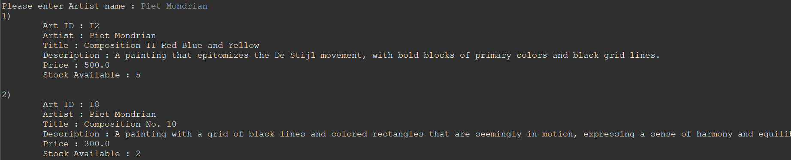
- Customer can search all the artwork available by choosing option 3 and searching by the artist name. If the artwork available in UX Gallery, it will display accordingly on the screen.

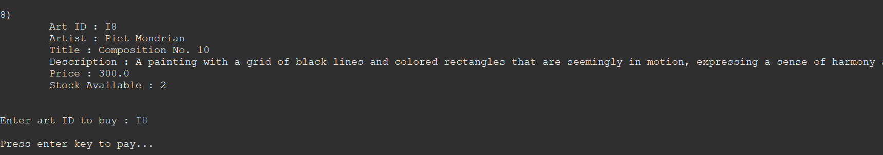
- Customer can purchase the artwork by choosingg option 4. After choosing option 4, all the artwork will be displayed and customer can purchase by choosing the Art ID that has given to each artwork.

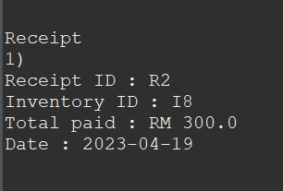
- Customer can view their receipt by choosing option 5. It will display the customers receipt ID and the total amount of their purchases.

Admin Login


- There is one administrative that can display all the customer and staff details that are in UX Gallery.

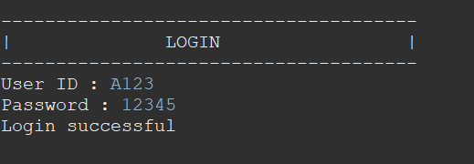
- In order to login to admin account the user ID is A123 and the password is 12345.

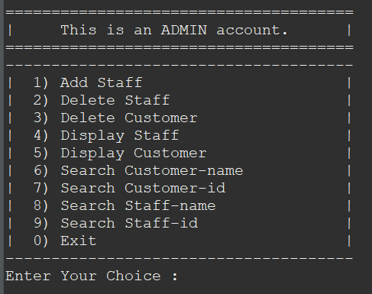
- There are many options in the admin account. Admin has access to add new staff to UX Gallery and display all staff details in this account. Admin also can display customer list and delete the unwanted customer details. Admin can delete the staff and customer by entering their ID. Not only that, admin can search staff and customer using their name or ID.

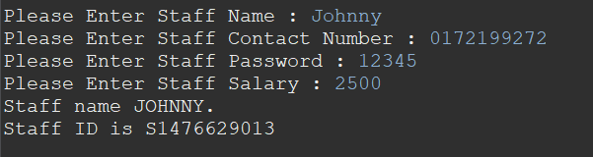
- Admin can add new staff by choosing option 1. After choosing option 1, the program will ask staff name, contact number and requested salary. The staff will be given a staff ID and password that has been set by the administrator. The staff later can login using the staff ID and the password.

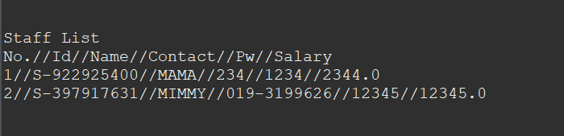
- Admin can display the staff list by choosing option 4. The program will display all the staff list including their name, staff ID with their salary details.

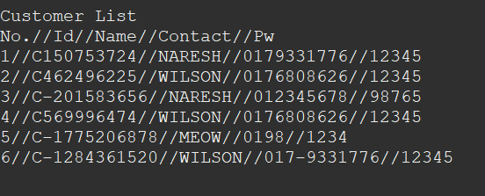
- Admin can display all the customer list by choosing option 5. The program will display all the customer list inluding their name, customer ID and the their contact.

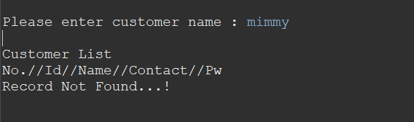
- Admin can search for customer using their name or customer ID by choosing option 6 and 7. Not only that, admin can also search staff using their name or staff ID by choosing option 8 and 9. If the record is found, it will display on the screen elsewhere if not found it will show “Record Not Found”.

Staff Login

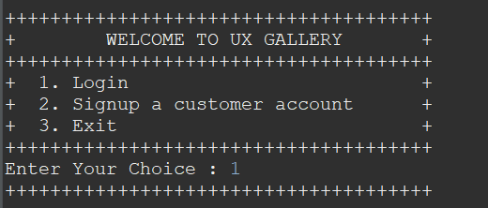
- Staff can login after admin created a new staff acoount in administative account. After getting staff ID and password from admin account. Can refer back to Admin Login step 3.

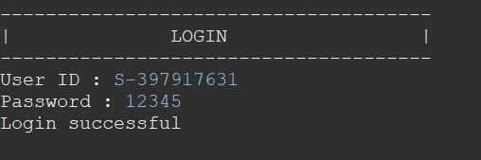

- Staff can login us their staff ID and password that admin has set.

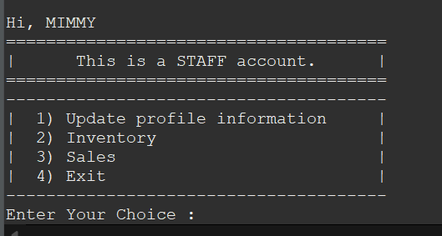
- After logingg in using correct staff ID and password, staff can login to staff account. The staff account has 3 options.

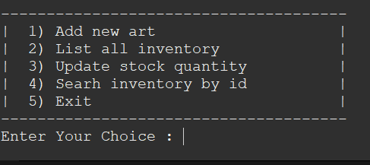
- After choosing option 2 from staff account “Inventory”, the program will display 4 option to check the inventory. Staff able to update the UX Gallery inventory stock in this option.

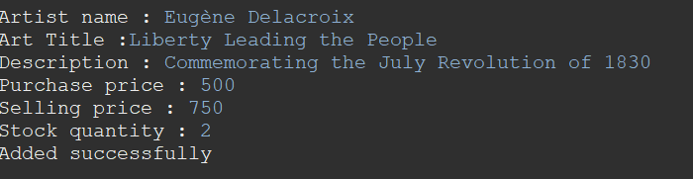
- Staff can add new art to inventory by choosing option 1 and listing all the details of the painting such as artist name, art title and description along with the prices. The new artwork will be added to the inventory after adding all the details.

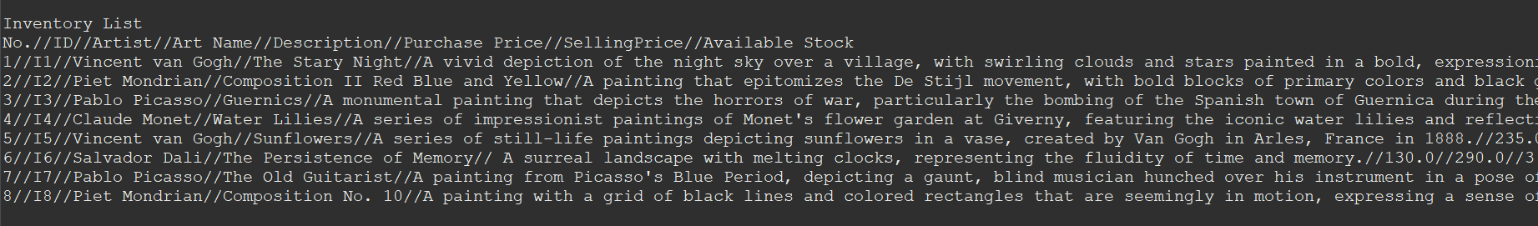
- Staff can view the inventory list by choosing option 2 which is listing all the artwork in the UX Gallery. The program will list the artist name, art title along with price details.

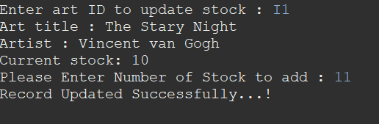
- Staff can update artwork stock quantity by choosing option 3. Staff can update the stock of the artwork by entering the art ID and then change the stock quantity. After changing the stock, the program will display “Record Updated Successfully”.

- Staff can search for art inventory using art ID by choosing option 4. If the entered art ID is found, the artwork details such as artist name, art name, description along with price details will be displayed to the screen. If the art ID is not found, “Record Not Found…!” will be displayed to the screen.


- Staff can check the sales of UX Gallery by choosing option 3.

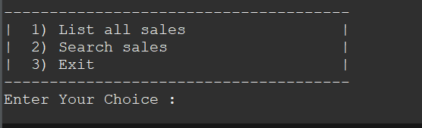
- After choosing the Sales option, staff get access to 2 options which are displaying the sales and searching the sales for UX Gallery.

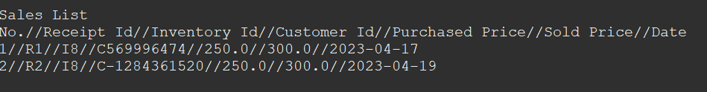
- After choosing option 1, the program will display the sales list of UX Gallery. The details that will displayed on the screen are receipt number, customer ID along with price details.

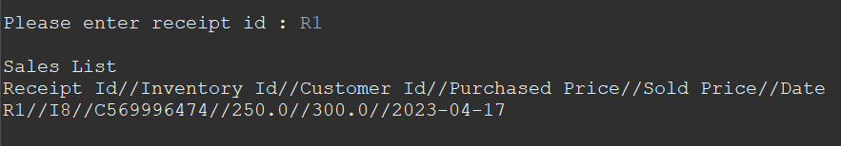
- After choosing option 2, which is “Search Sales”, the staff can search the sales by entering the receipt ID. If the receipt matches, the details will be displayed on the screen.

